Physics 131 Equations chapters 2-5

Chapter 2: One-Dimensional Kinematics

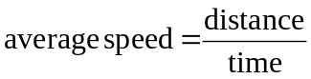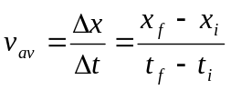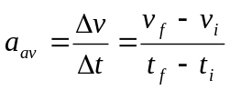

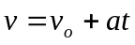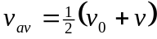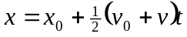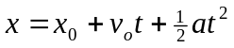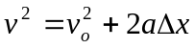

Chapter 3: Vectors in Physics

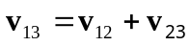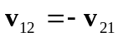

Chapter 4: Two-Dimensional Kinematics

basic equations of projectile motion:
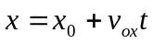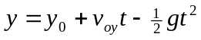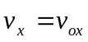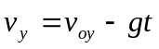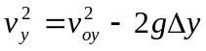

Chapter 5: Newton’s Laws of Motion

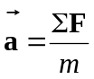

Physics 131 Spring, 2016 Test #1 Name ________________________

Part A: Short Answer

- A ball is thrown straight up in the air with an initial velocity of 3.00 m/s. Choosing up to be the positive direction, what is the ball’s acceleration at the very top of its trajectory?

- 0 m/s² b) 3.00 m/s² c) -3.00 m/s² d) 9.81 m/s² e) -9.81 m/s²

- Below is a graph of the velocity vs. time for an object moving on a straight track. During the 10.0 s shown…
v (m/s)
8.0

2.0
10.0 t(s)
What is the object’s average velocity? ____________

What is the object’s acceleration? ___________

What is the object’s displacement? ______________

Is the object moving in the positive direction or the negative direction? _____________________
3) At the right is a graph of position vs. time for a car moving along a straight 1-D path.
x (m)
20 m

10 m
5s 10 s 15s 20 s t (s)

What is the car’s velocity at t = 12 s? ______________

What is the car’s velocity at t = 17 s? _______________

What is the car’s acceleration at t = 5 s? _____________

- Consider a person standing still on the floor. The two forces acting on the person are weight and normal. Are these two forces equal in magnitude and opposite in direction? _________ How do you know?

Are these two forces an “action-reaction” pair as described by Newon’s 3rd law? _____________

- Give the direction of the net force on the object in each case. If the net force is zero, write “none.”
a) a box resting on the floor ________________________
b) a box sliding down an inclined plane at constant speed __________________
c) a person who has just left a diving board and is on the way up to the peak of her dive (Neglect air resistance.) ___________________

- Vector A is 4 units long and points in the positive x direction. Vector B is 7 units long and points in the negative x direction. Give the magnitude and direction of
- A + B ____________________________ b) A – B ___________________________

- Ball A is thrown horizontally off a bridge while a second, identical ball (ball B) is dropped off the bridge. Tell whether each of the following is greater for A, greater for B, or the same for both. (Ignore air resistance.) a) time to reach the water below ___________________
b) speed upon reaching the water __________________
c) acceleration while in the air _____________________
Part B: Problems Please show your work.

- A soccer ball is kicked from the ground over a level field such that it has an initial velocity of 12.5 m/s at an angle of 40.0°.

- How long is the ball in the air before landing back on the level ground? (Ignore air resistance.)

- What is the maximum height reached by the ball?

- How fast is the ball moving at the moment when it is at its maximum height?

- Suppose you want the ball to land exactly on the top of an inverted barrel that is 1.20 m tall. How far away from the kicker should you place the barrel, assuming the same initial velocity as before? (In other words, at what horizontal distance from the kicker will the ball be 1.20 m above the ground while on its way down?)

2) A 4.00 kg box is pulled up a frictionless inclined plane by a 25.0 N force that is applied parallel to the plane. The angle of the incline is 30.0°.

- Draw a free-body (or force) diagram for the block on the diagram below. Label all forces.

- Apply Newton’s Second Law to the direction parallel to the plane and find the block’s acceleration.

- Two forces are applied to the box shown in an overhead view below. One force is 13.2 N at an angle of 90.0° above the positive x-axis, and the other is 15.0 N at an angle of 35.0° below the negative x-axis. Assume friction is negligible. Find the net force (magnitude and direction) on the box.
35.0°

15.0 N

13.2 N

- You get into an elevator and push the up button. The elevator accelerates upward with a magnitude of 1.30 m/s². Suppose your weight is 120 lbs, which (in SI units) is 534 N.

- Draw a force diagram for you. Then apply Newton’s 2nd law and find your apparent weight (which is equal to the normal force on you) during the time the elevator is accelerating. (Give result in newtons.)

- The elevator now continues upward at a constant speed. Is the net force on you during this time positive, negative or zero? __________________________

- A car is traveling in a straight line in the positive x direction at a speed of 8.00 m/s. At time t = 0, the driver begins braking and the car comes to a stop uniformly in a distance of 20.0 m. Qualitatively sketch graphs of position vs. time, velocity vs. time, and acceleration vs. time for the car. Then, find the time it takes the car to travel the 20.0 m and its acceleration during this time.
t
x
v
a
t
t

